IB Goals
- to develop your power of expression in both oral and written communication
- to develop the ability to form independent literary judgments and support ideas
Your Tasks
- Choose one of the following conflicts/themes from Persepolis:
  - Identity
  - War and Revolution
  - Faith
  - Feminism
  - Marxism
- Create a product that demonstrates a struggle in your life that is analogous to Marji’s. It should follow the basic plot structure so that it is a complete “tale.” It should mirror Persepolis’ pacing, symbolism, and general structure.
- Your product choices:
  - A Graphic Story: Your graphic story must be at least ten pages and/or 50 panels. You must include shading and/or color, three different types of panel transitions, emanate, bleed or splash, voice over, two different types of speech bubbles, and variations of borders.
  - A Film: Your film must be at least three minutes long. It must have transitions that mirror those of graphic novels. It should have a soundtrack, dialogue, costuming, and camera techniques that mirror the development.
  - A Dance: Your dance must be three to four minutes and can be filmed. The dance must be paced appropriately and tell a story. It should have appropriate costuming, make up, and soundtrack. It can be, however, avant garde.
  - A Reflective Essay: You must write a reflective essay in which you explore your journey through the struggle. It should be written in narrative form and follow a basic story arc. You should also include pacing, dialogue, and movement.
  - A Musical Composition: You should perform and record a three (or more) minute song that clearly mirrors your struggle. It must also follow a narrative arc.
- You may choose to work independently or collectively in groups of (up to) four. Whining about group members you chose to work with and who didn’t do their job will elicit the following:
  - 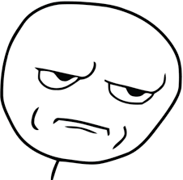

You will be graded using the following rubric:

 | 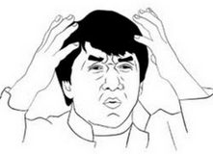  0-10 | 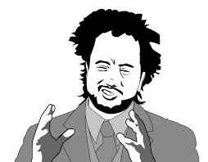  11-15 | 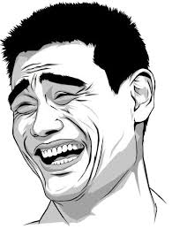  16-20
You met the requirements outlined above by your chosen genre.
Your product clearly reflects aligns with the chosen theme
You have a clear plot with conflict and character development.
Your pacing is appropriate and mirrors character development.
You are able to evoke reader/viewer/listener emotion through your product.

