Your Task is to Research a Historical event through the arts. First you must research the basic facts of the event. Be familiar with the forces involved and the major issues that caused the event. Then, you need to find the following that tell the story of the art:
- Two pieces of visual art
- Two pieces of performing art
- Two pieces of literature
In an MLA-formatted document, you must detail how each piece reflects the event. Each of 3our explanations should be at least two-hundred words. YOU MUST USE CITATIONS!!!!! IF YOU DO NOT HAVE A WORKS CITED, YOU WILL RECEIVE A 10 ON THE ASSIGNMENT.
Your art analyses should be prefaced by a 3X3 of the event itself.
John Doe
Ms. Old Person
Theory of Knowledge: 4A
21 Mar 2014
A Battle in Plaster: The Trojan War
Lust begets blood
Decade death decreed
Equine chicanery conquers
(Wikepedia Contributers)

Visual 1: The Battle of Paris and Menelaos
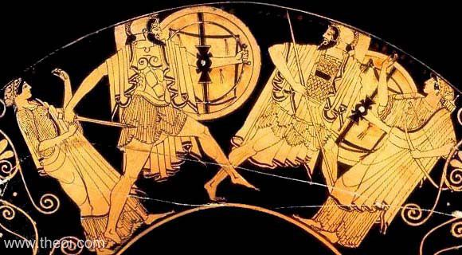 (Douris)
The above is imprinted on a vase and depicts scenes from Homer’s Illiad. In this scene, the primary figures of the war duel over Helen, the woman at the center of the battle. One primary image is the blackness of the vase as opposed to the gold figures that fight on it……….
YOU WILL BE GRADED USING THE IB WRITTEN WORK RUBRIC.

